**Munis MyWork mobile app**

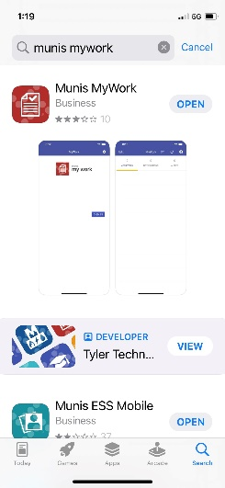

Download the ‘Munis MyWork’ App from the App Store.

You will see a screen that says ‘Service Location’. There is a spot to enter a QR code. Click on the small square that looks like a QR code, and you will bring up your camera. The code is found by logging into EERP on your computer. On the HUB screen there will be a cogwheel in the lower left corner. Click on that, and then on User Attributes. Scroll down to find the QR Code.

Once that is entered, you will enter your login credentials as usual.